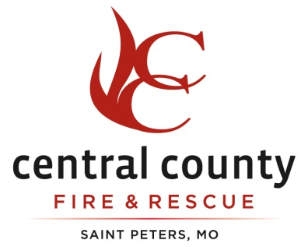

Official Minutes
Regular Business Meeting
February 27, 2018

The Central County Fire & Rescue Board of Directors held its Regular Monthly Business meeting on Tuesday, February 27, 2018, 6:00 p.m., at Headquarters, located at 1220 Cave Springs Blvd., St. Peters, MO 63376. Present were Chairman Dave Tilley, Treasurer Patricia Hamm and Secretary David Bell. Also present were Chief Dan Aubuchon, Assistant Chiefs Brian Ochs, Steve Brown, Gary Donovan, Shop Steward Tim O’Mara, Assistant Shop Steward Bryan Steinmeyer and Attorney Neil Bruntrager. The meeting was called to order at 6:07 PM by Dave Tilley.

Pledge of Allegiance

Dave Tilley led the Pledge of Allegiance.

Approval of the Amended Meeting Agenda

There was a motion to approve the agenda by David Bell and a second by Patricia Hamm.

Vote: Dave Tilley (Y) Patricia Hamm (Y) David Bell (Y)

Approval of the previous meetings minutes

There was a motion to approve the previous minutes by David Bell and a second by Patricia Hamm.

Vote: Dave Tilley (Y) Patricia Hamm (Y) David Bell (Y)

Reading of invoices over $2,500

Chief Aubuchon read all invoices over $2,500.00.

Authorization to pay bills

There was a motion to pay all bills by Patricia Hamm and a second by David Bell.

Vote: Dave Tilley (Y) Patricia Hamm (Y) David Bell (Y)

The floor was then opened to the public for comments and questions.

Mr. Owen Peters, a resident of Central County Fire and Rescue spoke to the Board of Directors.

Approval of Letter of Engagement for the 2017 Audit

Chief Aubuchon presented to the Board a proposal and a letter of engagement for Botz, Deal & Company, P.C. to conduct the 2017 audit for an estimated fee of $13,600.00. David Bell made a motion to approve the proposal from Botz, Deal & Company, P.C. There was a second by Patricia Hamm.

Vote: Dave Tilley (Y) Patricia Hamm (Y) David Bell (Y)

Treasurer’s Report

There was no Treasurer’s Report at this time, but the District’s financial reports were given to the Board.

Division Reports:

Operations: There was no Operations Report at this time.

Prevention: Assistant Chief Steve Brown gave an update for the Prevention Department.

Training: Battalion Chief Jim Densmore gave an oral update on the training for this month.

Purchase Requests/Staff Recommendations

There were no purchase requests or staff recommendations at this time.

Correspondence

Chief Aubuchon presented to the Board a thank you note from Fort Zumwalt East Band Boosters thanking the District for donating for their trivia night a dinner for six with the crew at one of the District’s Fire Stations.

Chief Aubuchon presented to the Board a thank you note from the 3N Staff at Progress West Hospital thanking the District for the love and support they showed everyone while one of our Captains was being treated there.

There was a motion by David Bell to go into Closed Session for personnel matters. There was a second by Patricia Hamm.

Vote: Dave Tilley (Y) Patricia Hamm (Y) David Bell (Y)

There was a motion by David Bell to close Open Session at 6:21 PM. There was a second by Patricia Hamm.

Vote: Dave Tilley (Y) Patricia Hamm (Y) David Bell (Y)

The Closed Meeting was adjourned at 7:19 PM and the Board returned to Open Session to announce the vote held in Closed Session.

Chief Aubuchon presented to the Board a memo stating that Firefighters Brian Baglin and Andrew Stecko have completed probation and should be removed from probationary status. David Bell made a motion to remove Firefighter Brian Baglin and Firefighter Andrew Stecko from probationary status. There was a second by Patricia Hamm.

Vote: Dave Tilley (Y) Patricia Hamm (Y) David Bell (Y)

David Bell made a motion to adjourn the meeting at 7:20 PM. There was a second by Patricia Hamm.

Vote: Dave Tilley (Y) Patricia Hamm (Y) David Bell (Y)

The meeting was adjourned at 7:20 PM.

Director____________________________

Director____________________________

Director____________________________

